Academic Task Number: 1 Course code: _CSE322
Date of allotment: 25/8/2022 Course title: Formal Language and Automata Theory
Date of submission:25/8/2022 Maximum Marks: 30
Academic Task Type: Online MCQ
Question Number | Question Statement
Q1 | Which of the following statement is true for 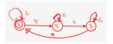  - any number of "a" followed by "b"  - any number of "b" followed by "a"  - Multiple of a where a mod 3 =0  - Containing aaa
Q2 | For a given non-deterministic finite automaton (NFA) with N states, the maximum number of states in an equivalent minimized DFA is at least.  (a) N^2  (b) 2^N  (c) 2N  (d) N!
Q3 | 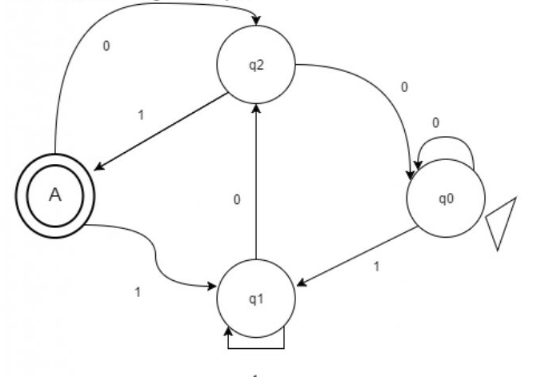.  Which of the following accepts this given DFA?  - X is a string such that it end with ‘101’  - X is a string such that it start 11 and end with 00  - X is a string such that it start with ‘101’  - None of Above
Q4: | In the given non kleen star operation that accep;ts the strings over {0,1} in FA that contain even number of 0 and 1.  - 01,0011,010101  - 0011,11001100  - 11,0011,110011100  - epsilon , 0011,11001100
Q5: | For the Given DFA , which of the following Language is accepted by this DFA.  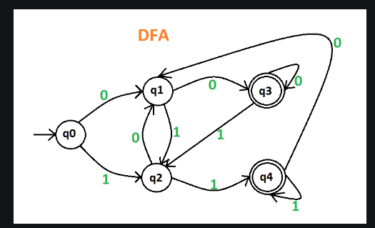  - Language that have strings either 00 or 11 at the end .  - Language that have strings start with 00 and end with 11  - Language that have strings 011 as substring  - Language that have strings 00 and 11 at the start
Q6: | Choose any one option for the language that is accepted by given NFA .  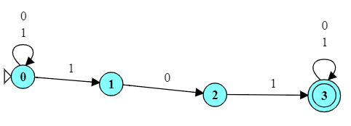  - all strings containing 101  - all strings beginning with 101  - all strings ending with 101  - only for 101 string
Q7: | How many states does Minimum DFA requires to construct a language where all string end with "ab"?  - 4  - 5  - 3  - 2
Q8: | The Minimum number of states in a problem is required which recognize the octal number divisible by 3.  - 1  - 2  - 3  - 4
Q9: | 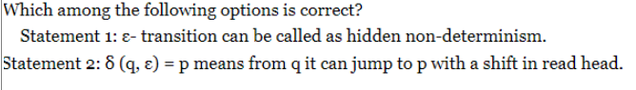  - Statement 1 and 2 both are correct  - Statement 1 and 2 both are wrong  - Statement 1 is correct and statement 2 is wrong  - Statement 1 is wrong and statement 2 is correct
Q10 | Choose the right option from below for statement 1 and 2.  Statement 1: All DFA are considered as NFA  Statement 2: All NFA are not considered as DFA  - Statement 1 is wrong and Statement 2 is correct  - Statement 1 and 2 both Wrong  - Statement 1 is correct and Statement 2 is wrong  - Statement 1 and 2 both Correct
Q11 | Choose one of the following for NFA if it is Non-Deterministic  - The result is undetermined  - The choice of path is non –deterministic  - The state to be transited next is non –deterministic  - All of the above mentioned
Q12: | In the minimal DFA for the given DFA , how many states are there?  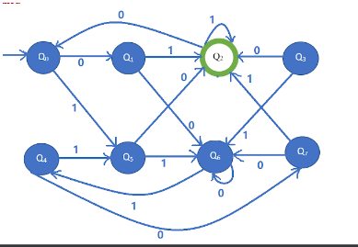  - 5  - 4  - 6  - 3
Q13 | Choose the correct number of elements present in the ε-closure(A) in the given Transition Diagram .  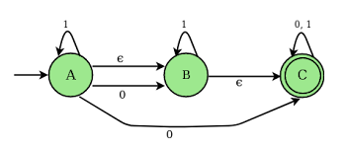  - 1  - 2  - 3  - 4
Q14 | Which of the following is the application of Automata theory?  - Searching of text  - Designing of compiler  - parsers for the grammars  - All of above mentioned
Q15 | Which among the following is the missing transition in the given DFA for the language that accepts the strings start with 'a' and end with 'b'  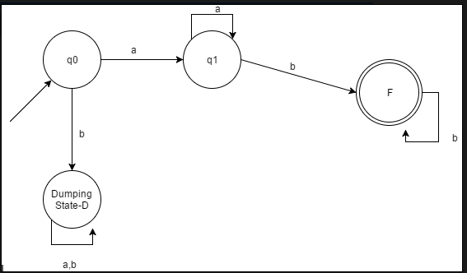  - δ (q0, a) =q0  - δ (F, a) =q1  - δ (q1, a) =D  - δ (F, a) =D

